Author: - Senior Leadership Team
Date of Issue: - July 2023
Review Date: - July 2024

St. John’s C of E Primary Academy
Charging and Remissions Policy
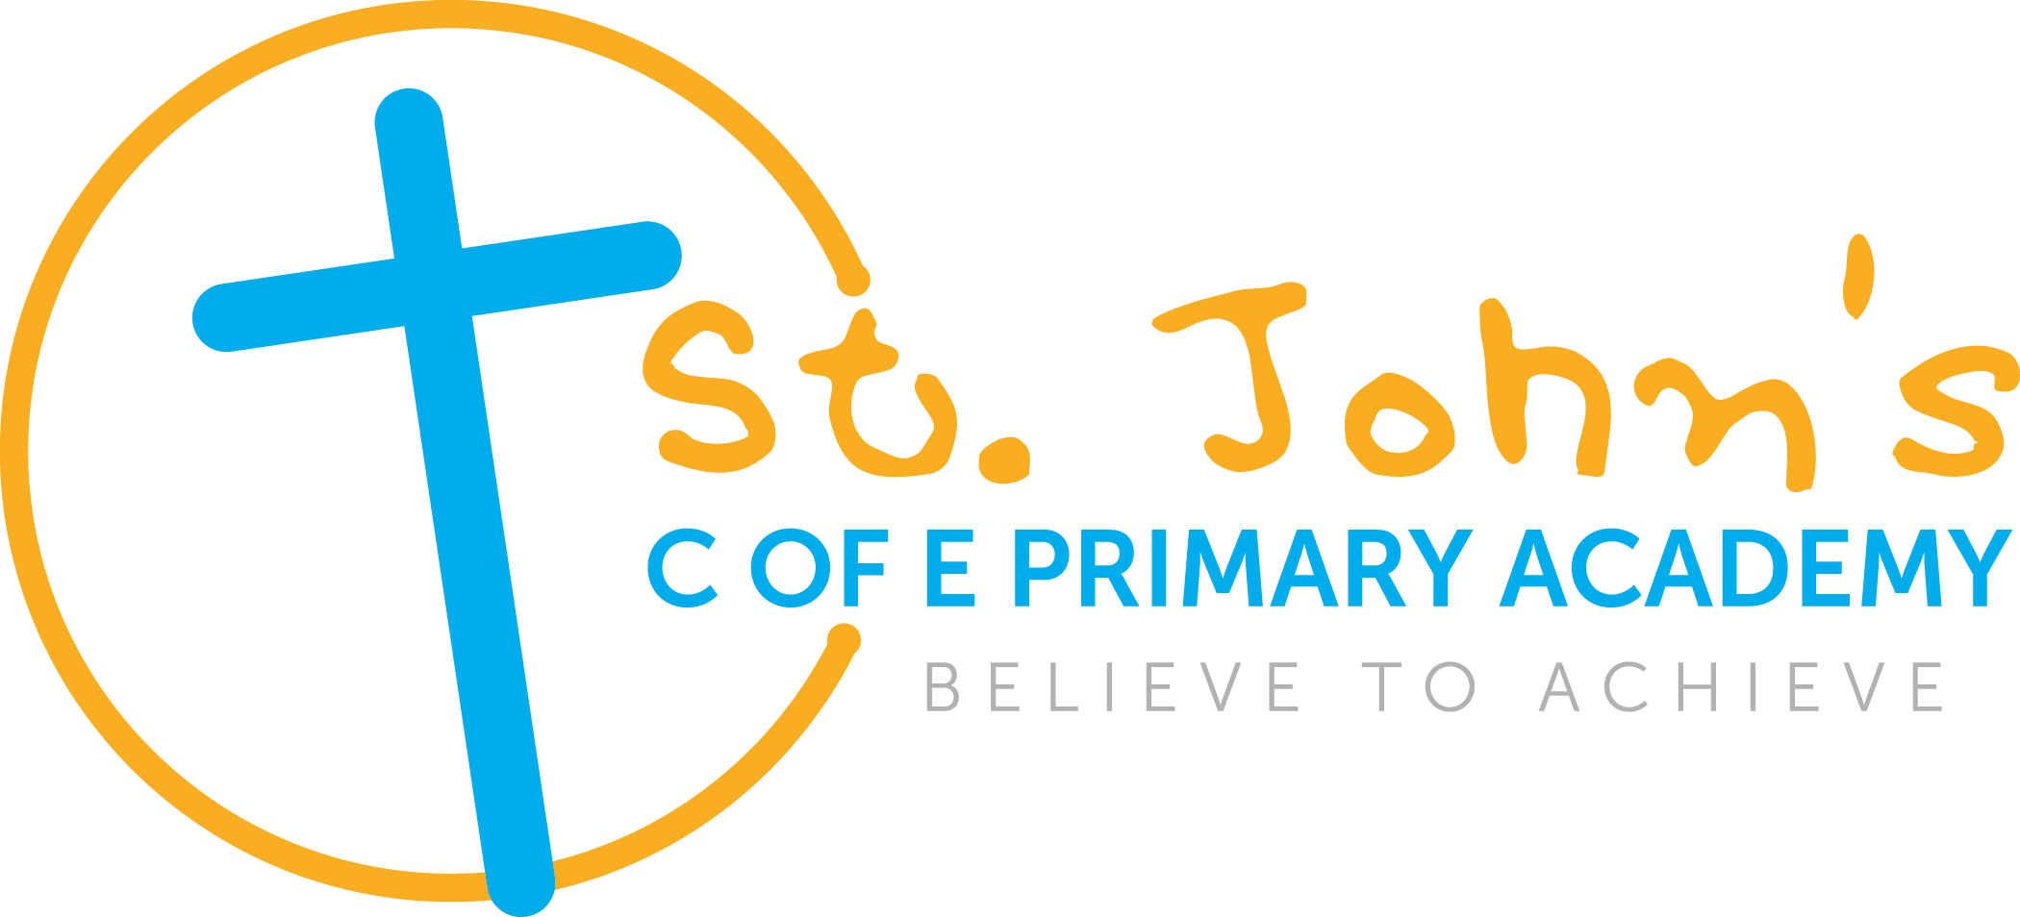

St. John’s C of E Primary Academy
Charging and Remissions Policy

‘Believe to Achieve’
Introduction
All education during school hours is free. We do not charge for any activity undertaken as part of the National Curriculum.
This policy is monitored by the Local Academy Committee , and will be reviewed annually or earlier if necessary.
Prohibition of Charges

The Local Academy Committee recognises that the legislation prohibits charges for the following:
• education provided during school hours (including the supply of any materials, books, instruments or other equipment);
• education provided outside school hours if it is part of the National Curriculum, or part of a syllabus for a prescribed public examination that the pupil is being prepared for at the school, or part of religious education;
• tuition for pupils learning to play musical instruments if the tuition is required as an essential part of the National Curriculum.
• entry for a prescribed public examination, if the pupil has been prepared for it at the school;
• education provided on any trip that takes place during school hours;
• education provided on any trip that takes place outside school hours if it is part of the National Curriculum, or part of a syllabus for a prescribed public examination that the pupil is being prepared for at the school, or part of the schools basic curriculum for religious education;
• Supply teachers to cover for those teachers who are absent from school accompanying pupils on a residential trip;
• transporting registered pupils to or from the school premises, where the local education authority has a statutory obligation to provide transport;
• transporting registered pupils to other premises where the Local Academy Committee or local education authority has arranged for pupils to be educated;
• transport provided in connection with an educational trip
Voluntary contributions
When organising school trips or visits to enrich the curriculum and the educational experience of the children, the school invites parents to contribute to the cost. All contributions are voluntary. If we do not receive sufficient voluntary contributions, we may have to cancel a trip. If a trip goes ahead, it may include children whose parents have not paid any contribution. We do not treat these children differently from any others.
If a parent wishes their child to take part in a school trip or event, but is unwilling or unable to make a voluntary contribution, we do allow the child to participate fully in the trip or activity.
The following is a list of additional activities, organised by the school, which require voluntary contributions from parents. These activities are known as ‘optional extras’
• visits to museums;
• sporting activities and those which require transport expenses;
• outdoor adventure activities;
• musical events.
Residential visits
If the school organises a residential visit in school time, or mainly in school time, which is to provide education directly related to the National Curriculum, we do not make any charge for the education element. However, parents are obliged to at least pay for the residential expenses of such trips, and we also ask parents to contribute to the full cost of the travel and activity expenses as these are beyond the scope of our main school budget.
A savings scheme will operate to allow parents to spread the cost of such trips over a longer period of time.

Music tuition

All children study music as part of the normal school curriculum. We do not charge for this. There will be a charge for individual and group music tuition if this is not part of the National Curriculum.

Remissions Policy
Those parents in receipt of one or more of the credits below may be offered assistance in paying for the trip or a longer period of instalments will be made available to enable their child to access the activity.
- Income Support
- Income-based Jobseeker's Allowance
- Income-related Employment and Support Allowance
- Support under Part VI of the Immigration and Asylum Act 1999
- The Guarantee element of State Pension Credit
- Child Tax Credit, provided they are not entitled to Working Tax Credit and have an annual income of £16,190 or less
- Working Tax Credit 'run-on' - the payment someone may receive for a further four weeks after they stop qualifying for Working Tax Credit.

