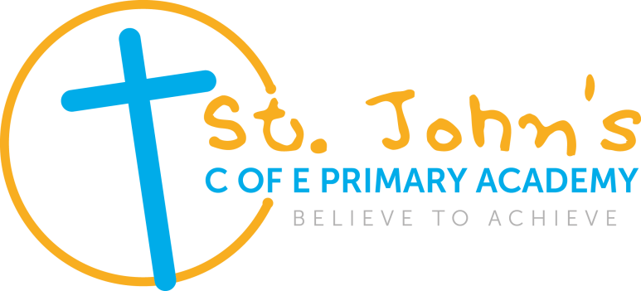


JOB DESCRIPTION

JOB TITLE: Class teacher (preferably with EYFS experience or interest)

LOCATION: St John’s C of E Primary Academy

GRADE: M1 – M6

PURPOSE OF JOB:

- To carry out the duties of the role in accordance with the School Teacher’s Pay and Conditions Document and other relevant statutory provisions.
- To carry out professional duties and to have responsibility for an assigned class.
- To be responsible for the day-to-day work and management of the class and the safety and welfare of the pupils, during on-site and off-site activities.
- To promote the aims and objectives of the academy and maintain its philosophy of education.

RESPONSIBILITY LINKS

Reports to: The Executive Principal
MAIN ACTIVITIES:

Teaching and learning:

- To plan, develop and deliver high quality lessons that cater for the needs of the whole ability range within their class within the context of the academy’s plans, curriculum and schemes of work
- To ensure the classroom environment is engaging and inspiring with a focus on working walls and celebration of children’s work.
- Promote the safety and well-being of pupils
- Establish a safe and stimulating working environment for pupils, rooted in mutual respect
- Take responsibility for promoting good and courteous behaviour both in classrooms and around the academy in accordance with the school’s behaviour policy
- Maintain good order and discipline among pupils through managing classes effectively, using approaches which are appropriate to pupils’ needs
- Have high expectations of behaviour and establish a framework for discipline with a range of strategies using praise, sanctions and rewards fairly and consistently
- Direct and supervise support staff assigned to them and where appropriate, other teachers
- Have a clear understanding of the needs of all pupils including those with special educational needs, those of high ability, those with English as an additional language, those with disabilities and be able to use and evaluate distinctive teaching approaches to engage and support them
- Contribute to the design and provision of an engaging curriculum within the relevant subject area(s)

Monitoring, Assessment, Recording, Reporting:

- Assess, monitor, record and report on the learning needs, progress and achievements of assigned pupils
- Make effective use of data to monitor and evaluate pupil progress across the curriculum and to inform teaching and learning planning
- Participate in arrangements for preparing pupils for qualifications and external examinations
- Use relevant data to monitor progress, set targets and plan subsequent lessons
- Give pupils regular feedback both verbally and through accurate marking and encourage pupils to respond to the feedback.
- To monitor pupil progress, keeping pupil records that include assessment outcomes and targets set at regular intervals in line with academy policy, to enable all pupils to achieve their full potential

Curricular Knowledge and Understanding:

- Have a thorough and up-to-date knowledge and understanding of the National Curriculum programmes of study, level descriptors and specifications for all relevant areas of the Curriculum.
- To understand and plan the EYFS curriculum effectively
- Demonstrate a critical understanding of developments in the subject and curriculum areas and promote the value of scholarship
- Demonstrate an understanding and take responsibility for promoting high standards of literacy, articulacy and the correct use of standard English
- Have a secure knowledge of the relevant subjects and curriculum areas. Foster and maintain pupils’ interest in the subject and address misunderstandings

Professional Standards and Development:

- Develop effective professional relationships with colleagues, knowing how and when to draw on advice and specialist support
- Take responsibility for improving teaching through appropriate professional development, responding to advice and feedback from colleagues
- Communicate effectively with parents and carers with regard to pupils’ achievements and well-being and provide feedback on a pupil’s progress at parents’ evenings and other meetings
- Critically evaluate resources and teaching, using this knowledge to improve the quality of teaching and learning
- Assist in the development of the School Curriculum in line with the academy’s Improvement Plan
- Contribute to the development, implementation and evaluation of the academy’s policies, practices and procedures in such a way as to support the academy’s values and vision

Continuing Professional Development – Personal:

- Take responsibility for personal professional development, keeping up to date with developments and changes in the School Curriculum, which may lead to improvements in teaching and learning
- Undertake any necessary professional development as identified in the academy Improvement Plan taking full advantage of any relevant training and development available
- Implement the use of new technologies that enhance teaching and learning including podcasts and interactive whiteboards
- Carry out reflective practice exercises to move classroom practice, teaching and learning forward

Other Duties:

- Make a positive contribution to the wider life and ethos of the academy
- To follow and actively promote the academy’s ethos and policies
- Committed to St Chad’s Academies Trust vision
- Comply with the Health and Safety policy and undertake risk assessments as appropriate
- Demonstrate consistently the positive attitudes, values and behaviour which are expected of pupils



TEACHER: PERSON SPECIFICATION
E= Essential D = Desirable A=Application I = Interview O = Other | E | D | How assessed
Professional Knowledge and Understanding  - A thorough understanding of what constitutes effective teaching and learning.  - A thorough knowledge and understanding of effective monitoring, evaluation and assessment.  - A thorough knowledge and understanding of effective practice in teaching all aspects in EYFS, KS1, KS2 or all.  - Understand when and how to seek advice and support.  - A thorough knowledge and understanding of effective inclusive practices.  - Understanding the Christian foundation of the academy whilst living out the values of the academy | ✓  ✓  ✓  ✓  ✓ |  | A,I
Skills  - Well-developed interpersonal skills.  - Able to communicate effectively orally and in writing to a range of audiences.  - Able to plan, organise and prioritise.  - Able to manage good communication systems. | ✓  ✓  ✓  ✓ |  | A,I
Abilities and Attributes  - Able to focus on the needs of the children in all aspects of their professionalism.  - Able to lead, support and challenge others, co-ordinating their work.  - Able to think creatively and imaginatively to anticipate and solve problems and identify opportunities.  - Able to inspire the confidence of others.  - Able to develop and maintain good relationships with staff, parents, pupils, governors and the community.  - Committed to own development as a professional.  - Able to reflect on own practice and identify areas for improvement. | ✓  ✓  ✓  ✓  ✓  ✓ | ✓ | A,I,O
Experience  - Successful teaching within KS1, KS2 or both.  - Successful management of an area of the curriculum.  - Experience of managing the performance of others. | ✓ | ✓  ✓ | A,I O
Qualifications  - Qualified Teacher Status (QTS)  - First degree or equivalent  - Higher Degree or further qualification  - Evidence of further professional development. | ✓  ✓  ✓ | ✓ | A
An awareness of, and commitment to, equality of opportunity | ✓ |  | A,I

